WEBSITE STRUCTURE & ARCHITECTURE
Tasks
1.Draw a sitemap diagram for a food delivery website like Zomato, showing main pages (Home, Search, Restaurant Details, Cart, Orders, Profile) and how they connect.

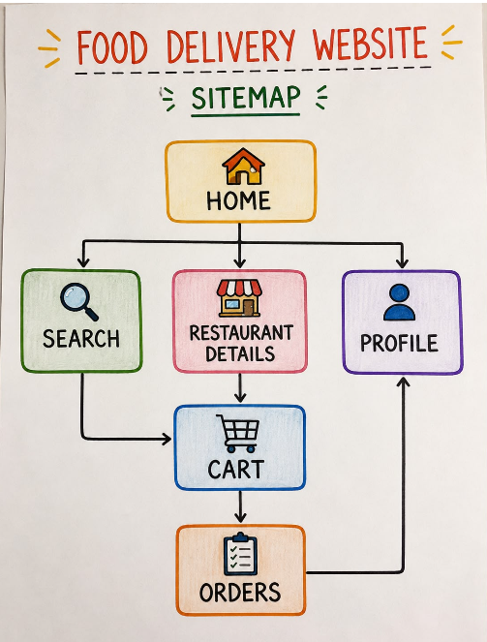

2.Create a folder structure for a basic movie review website (like BookMyShow) with separate folders for pages, images, CSS, and scripts. List the folder and file names you would include.

3.Write a short explanation (3-4 lines) of why clear website architecture is important for user experience on an e-commerce site like Flipkart.
=> Answer :
A clear website architecture helps users easily find the information they need. It provides simple navigation and reduces confusion. A well-organized structure also improves the overall user experience and makes the website easier to use. For an e-commerce website like Flipkart, clear categories and navigation help users quickly find and purchase products.

4.Pick any one app you use daily (Instagram, Spotify, Myntra, etc.) and list the main sections/pages you would include if you were designing its website version. Briefly describe the purpose of each section.<br><br><em><strong>Hint:</strong> Think about what users do most on that app and how you would organize those features on a website.</em>
=> Answer :
App Selected : Instagram
Section | Purpose
Home | Shows posts and updates from users.
Search | Helps users discover new content and accounts.
Profile | Shows user’s posts, followers and account information.
Messages | Allows users to communicate through direct messages.
Notification | Shows likes, comments, follows and other activities.
Settings | Allows users to manage account and privacy settings.

